Registration Now Open! as of Jan 15, 2026
Join snowfighters from across the region for two days of winter maintenance best practices, innovative materials, research insights, and hands-on learning. Whether you’re a maintenance worker, supervisor, or manager, this conference delivers the tools and connections you need for safer, more effective snow and ice control.

PRICING & DEADLINES*
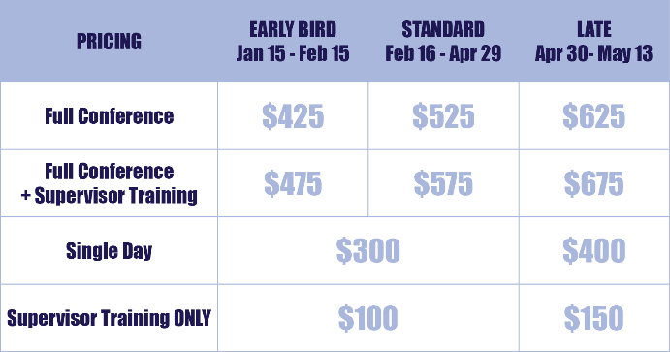
Early Bird Registration
January 15 – February 18, 2026
General Registration
February 16 – April 29, 2026
Late Registration
April 30, 2026 – May 13, 2026
*Subject to change, please see the website.
CONFERENCE HIGHLIGHTS
- Sessions led by winter maintenance and industry experts
- Vendor exhibits featuring the latest tools and technology
- Networking with snowfighters from across the Northwest
- Spokane’s unbeatable spring hospitality
👉 Visit the Conference Website
Find the full agenda, classes, pricing details, hotel information, and sponsorship opportunities.
Questions?
Email: info@pnsassociation.org

