Subject Line: Save the Date! ❄️ 2026 Pacific Northwest Snowfighters Conference – Spokane, WA
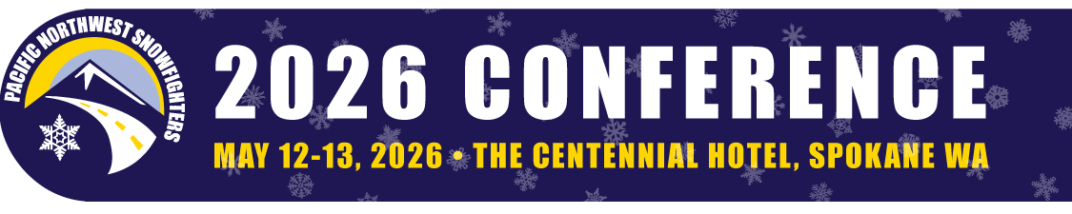
Get Ready for the 2026 PNS Conference – May 12-13 in Spokane!
The 2026 Pacific Northwest Snowfighters Conference is heading to Spokane, Washington – and you’re invited!
📅 Save the Date: May 12-13, 2026
📍 The Centennial Hotel, Spokane, WA
Join snowfighters from across the region for two days of best practices in winter road maintenance, innovative materials, research results, and networking. Whether you're a maintenance worker, supervisor or manager, this is your opportunity to connect with peers, explore cutting-edge practices, and prepare for safe, effective snow and ice control.
Highlights will include:
✔️ Educational sessions led by top industry experts
✔️ Vendor exhibits showcasing the latest technology
✔️ Networking with fellow snowfighters across the Northwest
✔️ And of course—Spokane’s spring charm and hospitality

Stay tuned—registration opens soon!
Sponsor / Exhibitor Registration – Open Now
Early Bird Registration - January 15, 2026
General Registration – February 16, 2023

👉 Visit the Conference Website for schedule for classes, pricing and sponsorship opportunities.
We can’t wait to see you in Spokane!
Pacific Northwest Snowfighters Conference Planning Committee
Questions? Contact us at info@pnsassociation.org

