PNS Email for One-to-One Sponsor Outreach
Note: quantities of sponsorships will change over time. See the website to check.
Subject Line: Sponor Opportunity – ❄️ 2026 Pacific Northwest Snowfighters
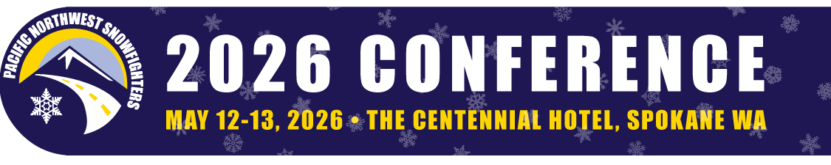
Dear [First Name],
The Pacific Northwest Snowfighters Conference returns May 11–13, 2026 at the Centennial Hotel in Spokane, WA, and I am pleased to invite your company to participate as a sponsor.
As you know, this event is the premier gathering for transportation and public works professionals across the Northwest—bringing 300+ decision-makers together to explore innovations, strategies, and partnerships in snowfighting and roadway maintenance.
Here’s why timing matters: sponsorships with exhibitor booths are currently open, but on October 13, 2025, exhibitor registration opens to the public. Once that happens, space will be available on a first-come, first-served basis—and both indoor and outdoor booths are expected to fill quickly. Sponsorship is the surest way to guarantee your organization’s visibility at this high-demand event.
Sponsorship Benefits
Every sponsorship includes:
- Exhibit space (6' tabletop, with optional outdoor add-on available)
- 1 complimentary registration + 1 discounted registration ($250)
- Company recognition (onsite guide, signage, website, and slideshow)
- Access to attendee registration list (for one-time marketing use)
Sponsorship Levels
Gold Sponsor $6,000, 5 Available
- 3 complimentary registrations and 3 discounted registrations ($250 each)
- Company collateral placement at registration desk
- Dedicated email marketing to PNS Snowfighters mailing list (sponsor content due April 1, 2026)
Silver Sponsor $4,250, 4 Available
- 2 complimentary registrations and 2 discounted registrations ($250 each)
- Dedicated email marketing to PNS Snowfighters attendee list (sponsor content due April 1, 2026)
Bronze Sponsor $2,750, 3 Available
- Highlighted “shout out” in a marketing email to all registrants
Onsite Sponsorships $2,000-$1,000
Available for (1) Breakfast, (3) Coffee Breaks, (2) Wednesday Night Reception, (2) Supervisor Training, and the Offsite Event. Each onsite sponsorship includes:
- Recognition as event sponsor (e.g., “Reception Sponsored by Your Company”)
The Supervisor Training begins May 11, with the full conference running May 12–13 (concluding at noon). Sponsorship ensures your organization is front and center with professionals from state transportation departments and public works agencies throughout the Pacific Northwest.
👉 Review details and secure your sponsorship today
We invite join us in Spokane. By sponsoring now, you’ll not only maximize visibility but also secure your place as we will sell out.
Sincerely,
<INSERT YOUR NAME HERE>
<TITLE>
On Behalf of the Pacific Northwest Snowfighters Association
Website: https://pnsassociation.org/
PS Email ErinI@meetingvisions.net to get on the list to receive direct emails about the conference.

