Subject Line: Registration Now Open! ❄️ 2026 Pacific Northwest Snowfighters Conference – Spokane, WA

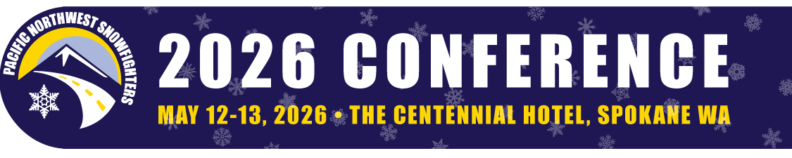
Register Today for the 2026 PNS Conference
May 12–13 in Spokane!
The 2026 Pacific Northwest Snowfighters Conference is heading to Spokane, Washington – and registration is officially OPEN!
📅 Conference Dates: May 12–13, 2026
📍 Location: The Centennial Hotel, Spokane, WA
Join snowfighters from across the region for two days of best practices in winter road maintenance, innovative materials, research results, and valuable networking. Whether you're a maintenance worker, supervisor, or manager, this event offers a unique opportunity to learn from peers, explore new technologies, and sharpen your skills for safe, effective snow and ice control.
Conference Highlights:
✔️ Educational sessions led by top industry experts
✔️ Vendor exhibits showcasing cutting-edge tools and technology
✔️ Networking with snowfighters from across the Northwest
✔️ Spokane’s signature spring charm and hospitality

Registration Is Now Open – Early Bird Rates Start Today! (January 15, 2026)
Early Bird Pricing (through February 15):
- Full Conference: $425
- Full Conference + Supervisors Training: $475
- Single Day: $300
- Supervisors Training Only: $100
General Rates Begin February 19:
- Full Conference and Full Conference + Supervisors Training each increase by $100.
Sponsor & Exhibitor Registration – Open Now
👉 Visit the Conference Website for the class schedule, full pricing details, and sponsorship opportunities.
We can’t wait to see you in Spokane!
Pacific Northwest Snowfighters Conference Planning Committee
Questions? Contact info@pnsassociation.org

